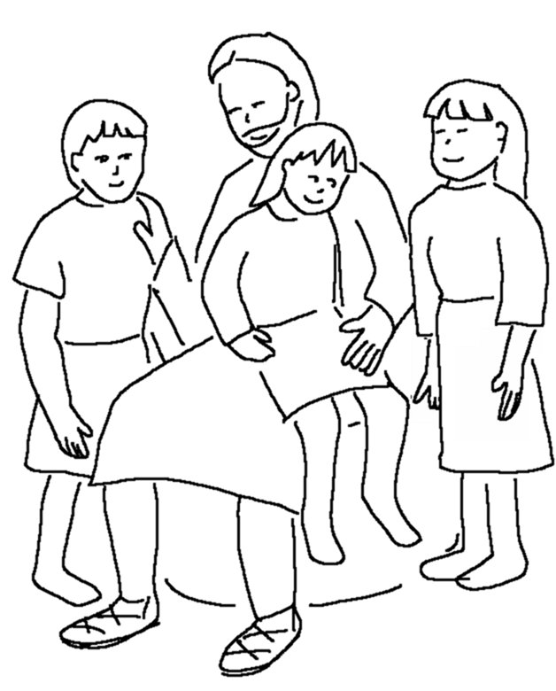
When everything is _ _ _ _ _, I will _ _ _ _ and get you, so that you will always be with _ _ where I am.
John 14:3_{NLT}

